Assembly and
Operation of the


Class AB Audio Amplifier Module
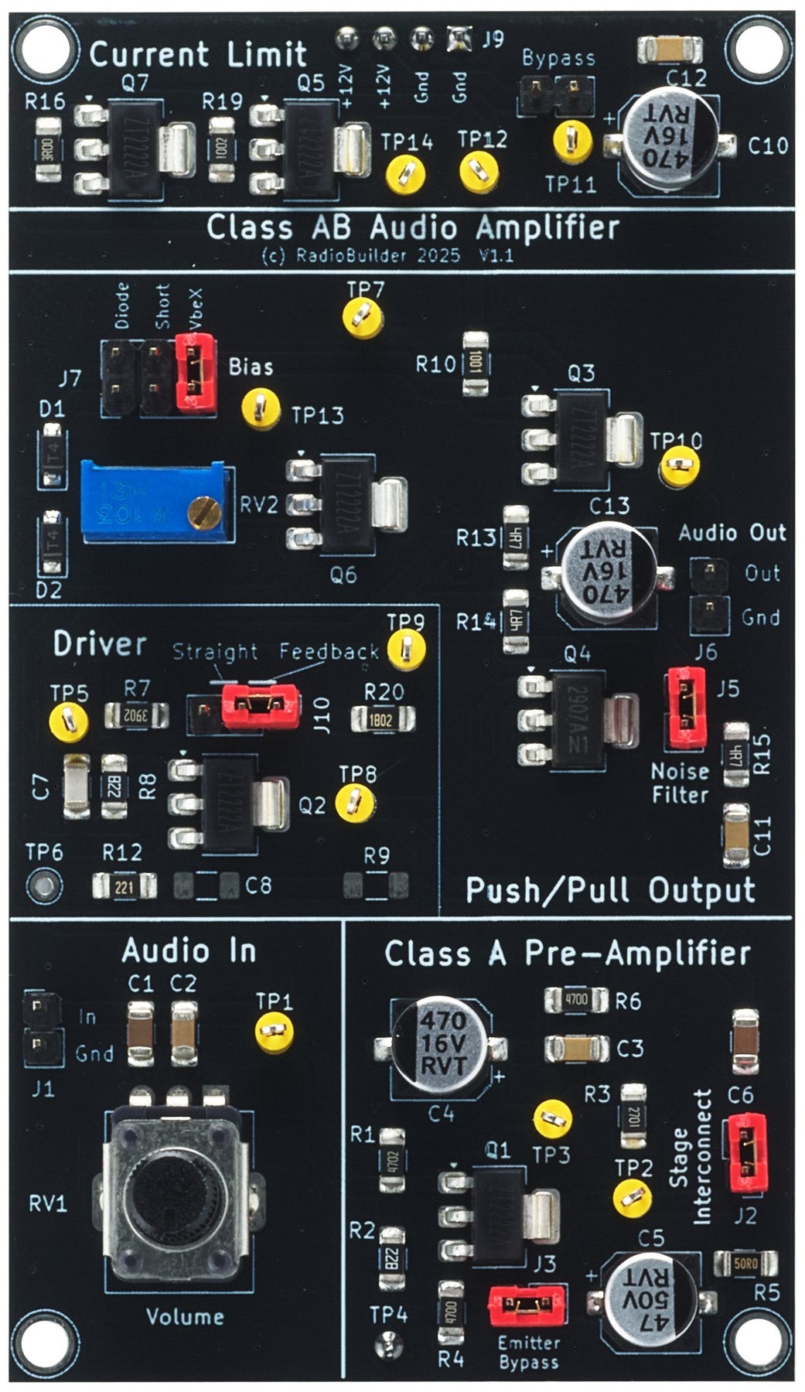
Component of the RadioLab
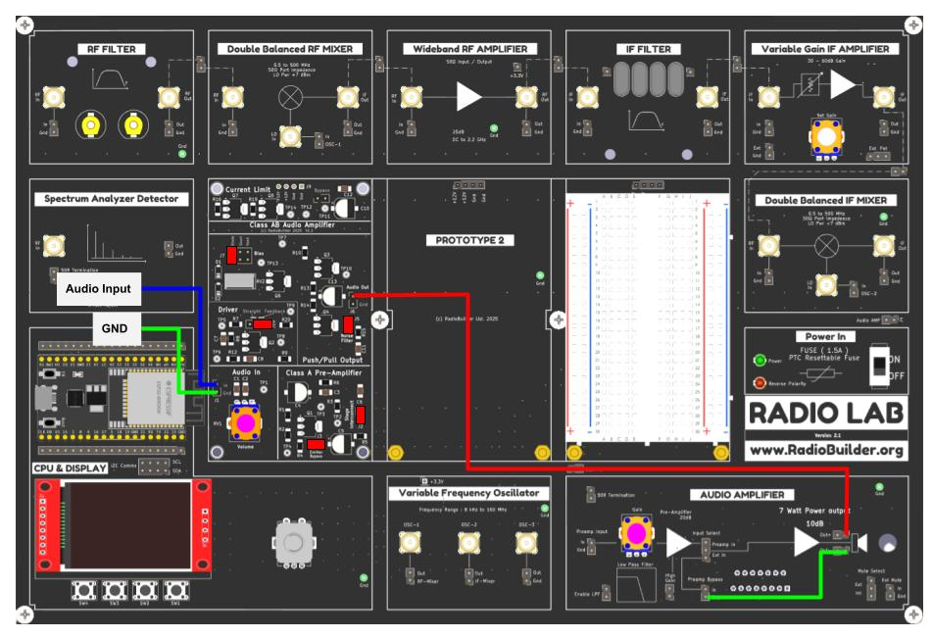
Contents
1.0 Audio Amplifier Overview 3
1.1 Audio Amplifier Module Specifications 3
1.2 Amplifier Classes 4
2.0 Audio Amplifier Theory 5
2.1 Theory of Operation 5
2.2 Connection Diagram 6
2.3 Jumper Configuration 6
2.4 Operation 7
2.5 Setting the Bias (VBE Multiplier) 7
3.0 Schematic Diagram 8
4.0 Circuit Description 9
4.1 Audio Input and Volume Control 9
4.2 Class A Pre-Amplifier 9
4.3 Driver Stage 10
4.4 Bias Network (J7) 12
4.5 Push-Pull Output Stage 14
4.6 Zobel Network (Noise Filter J5) 14
4.7 Current Limit 15
5.0 Signal Tracking 16
5.1 DC Test Point Voltages 16
5.2 AC Signal Tracking 16
6.0 Experiments 19
7.0 Assembly 21
7.1 Step 1 - Power Header 21
7.2 Step 2 - Complete Assembly 22

1.0 Audio Amplifier Overview
Audio power amplifiers have been at the heart of radio receivers since the 1920s, when valve (vacuum tube) output stages were first used to drive loudspeakers directly. The arrival of the transistor in the 1950s led to the complementary push-pull output stage, in which an NPN and a PNP transistor share the work of driving the load. This arrangement removed the need for a heavy output transformer and remains the basis of most discrete audio amplifiers built today.
Amplifiers are grouped into classes according to how much of each signal cycle the output devices conduct. Class A is simple and linear but wasteful. Class B is efficient but suffers from crossover distortion. Class AB combines the two by applying a small bias current to the output transistors so that both conduct around the zero-crossing point. The RadioLab Audio Amplifier Module lets the student switch between these operating modes and observe the effect directly on an oscilloscope.

1.1 Audio Amplifier Module Specifications
Parameter | Typical Value
Supply voltage | +12 V to +13.8 V (J9)
Topology | Class A pre-amp → driver → Class AB push-pull
Output devices | PZT2222A (NPN) / PZT2907A (PNP)
Speaker | 4 Ω or 8 Ω (J6)
Pre-amp gain | High / Low (J3)
Driver bias | Straight / Feedback (J10)
Output stage bias | Short / Diode / VBE multiplier (J7)
Output filter | Zobel network (J5)
Protection | tive current limit, bypass with J4
Output power (8 Ω, 1 kHz, 12 V) | 0.25 W typical (4 V pk-pk, no visible clipping)
Output power (8 Ω, 1 kHz, 13.8 V) | 0.32 W typical (4.5 V pk-pk, no visible clipping)
THD (1 kHz, 8 Ω, 0.21 W) | 0.69 %
THD measured with J4 fitted, J10 = Feedback, J7 = VbeX, 3.7 V pk-pk into 8 Ω.

1.2 Amplifier Classes
The table below compares the common linear amplifier classes. The bias jumper J7 on this module allows the output stage to be operated as Class B (Short) or Class AB (Diode or VbeX).
Class | Conduction Angle | Max Theoretical Efficiency
Class A | 360° | 25 % (resistive load), 50 % (transformer)
Class B | 180° per device | 78.5 %
Class AB | >180° per device | 50 – 78.5 %
Class D (switching) | Switched | >90 %

2.0 Audio Amplifier Theory
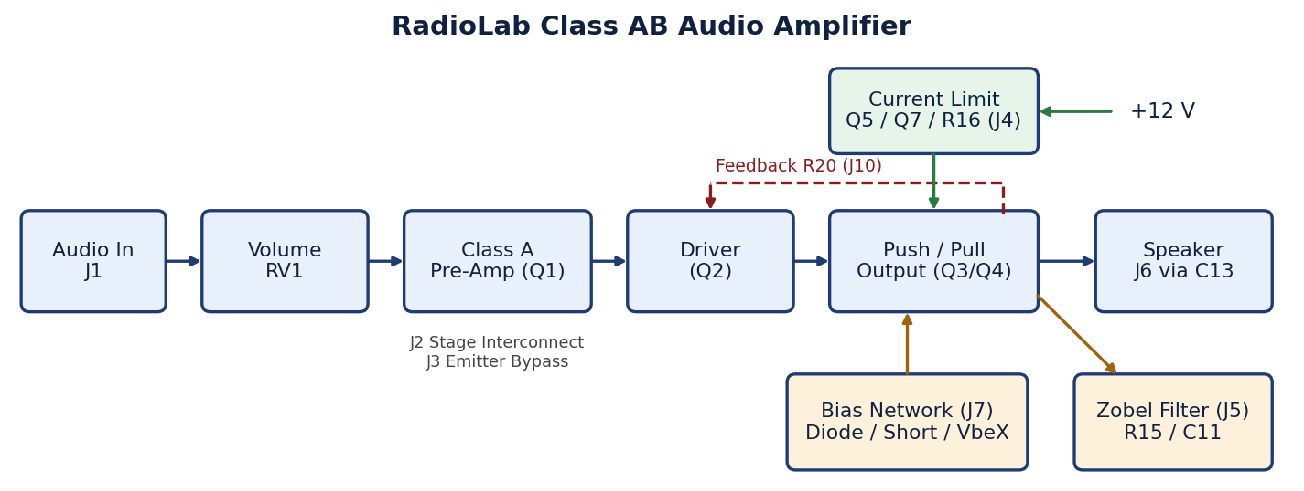
Block Diagram

2.1 Theory of Operation
The RadioLab Class AB Audio Amplifier is a three-stage discrete transistor amplifier designed to drive a 4 Ω or 8 Ω loudspeaker from a low-level audio source such as the FM Demodulator Module or an audio signal generator.
The audio signal enters at J1 and is AC-coupled through C1 to the volume control RV1. The wiper of RV1 feeds the Class A pre-amplifier Q1 through C2. Q1 is a common-emitter stage with voltage-divider bias, providing the majority of the voltage gain. The emitter bypass jumper J3 allows the gain to be switched between a high-gain (bypassed) and low-gain (unbypassed) setting.
The output of the pre-amplifier is routed through the stage interconnect jumper J2 and coupling capacitor C6 to the driver transistor Q2. Q2 is a second common-emitter stage whose collector current flows through R10 and the bias network, setting the DC voltage on the bases of the output transistors.
The bias network, selected with J7, places a small voltage between the bases of Q3 and Q4 (Bias+ and Bias−). This voltage determines the quiescent current of the output stage and therefore whether the stage operates in Class B or Class AB.
Q3 (NPN) and Q4 (PNP) form a complementary emitter-follower push-pull output stage. Q3 sources current to the load on the positive half-cycle and Q4 sinks current on the negative half-cycle. R13 and R14 are emitter ballast resistors that stabilise the quiescent current. The output is AC-coupled to the speaker through C13.
A negative feedback path through R20 (selected with J10) sets the DC operating point of the output at approximately half the supply voltage and reduces distortion. A Zobel network (R15, C11, selected with J5) keeps the load resistive at high frequency. The supply to the output stage passes through an active current limiter (Q5, Q7, R16), which can be bypassed with J4.

2.2 Connection Diagram
Connection Diagram

Note
Leave J4 (Bypass Current Limit) open when first powering the module. The current limiter protects the output transistors if the speaker output is shorted or the bias is set too high. Fit J4 only after the bias has been set (see 2.5).

2.3 Jumper Configuration
Jumper | Function | Default Position
J2 | Stage Interconnect – pre-amp to driver | Fitted
J3 | Emitter Bypass – high gain when fitted | Fitted
J4 | Bypass Current Limit | Open
J5 | Noise Filter – Zobel network | Fitted
J7 | Bias – Diode / Short / VbeX | VbeX
J10 | Driver bias – Straight / Feedback | Feedback

2.4 Operation
- Connect an audio signal generator to J1 (Audio In) and GND to Gnd
- Connect J6 (Audio Out) to a 4 Ω or 8 Ω speaker
- Set the jumpers to the default positions shown in 2.3
- Turn RV1 (Volume) fully anticlockwise, then apply power
- Set the bias (see 2.5)
- Adjust RV1 (Volume) until the signal at TP1 is 80 mV pk-pk

2.5 Setting the Bias (VBE Multiplier)
The bias is set with trimmer RV2 so that crossover distortion is just removed.
- Fit J7 in the VbeX position
- Turn RV2 fully anticlockwise. This gives minimum bias (Class B operation)
- Apply a 1 kHz tone from the signal generator and adjust RV1 until the signal at TP1 is 80 mV pk-pk
- Listen to the speaker, or connect an oscilloscope to TP10
- Slowly turn RV2 clockwise until the crossover distortion disappears – the harsh buzz is no longer heard, or the notch at the zero crossing is no longer visible
- Stop at this point. Turning RV2 further increases the idle current and heat without improving the sound

3.0 Schematic Diagram
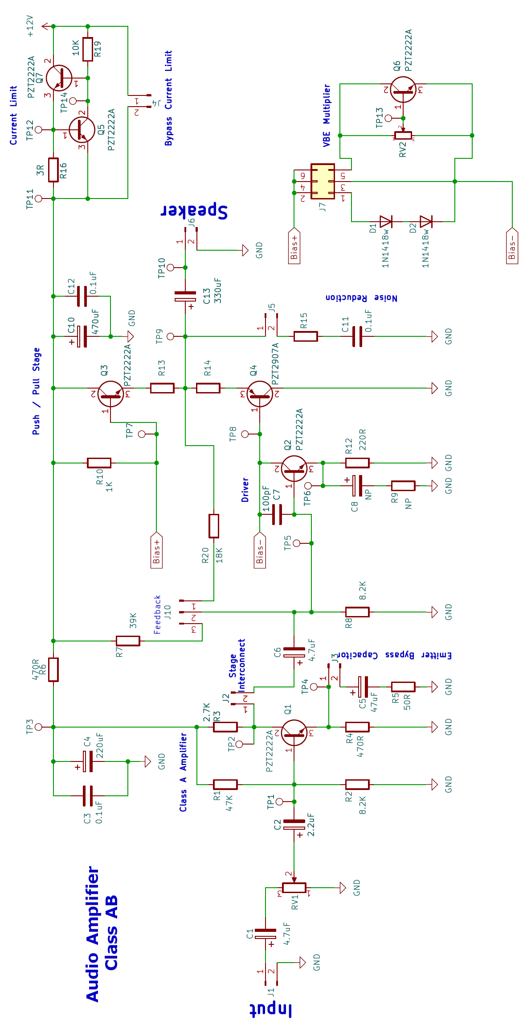
Class AB Audio Amplifier Module Schematic

4.0 Circuit Description

4.1 Audio Input and Volume Control
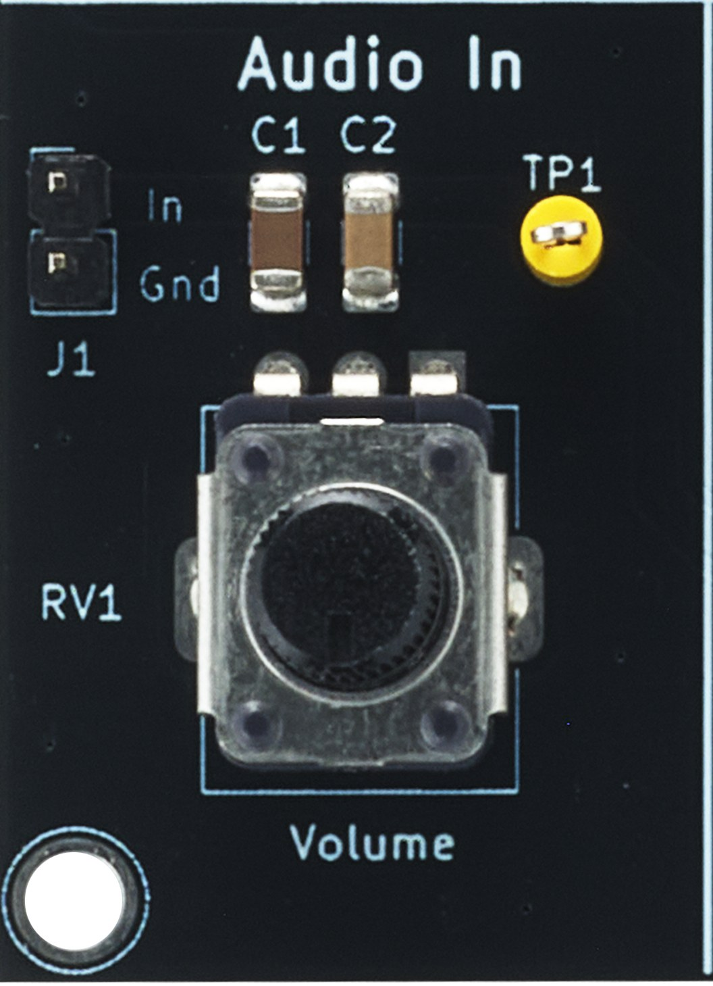
The audio input at J1 is AC-coupled by C1 to the volume potentiometer RV1. C1 blocks any DC voltage from the signal source. The RV1 wiper is coupled to the base of Q1 through C2.

4.2 Class A Pre-Amplifier
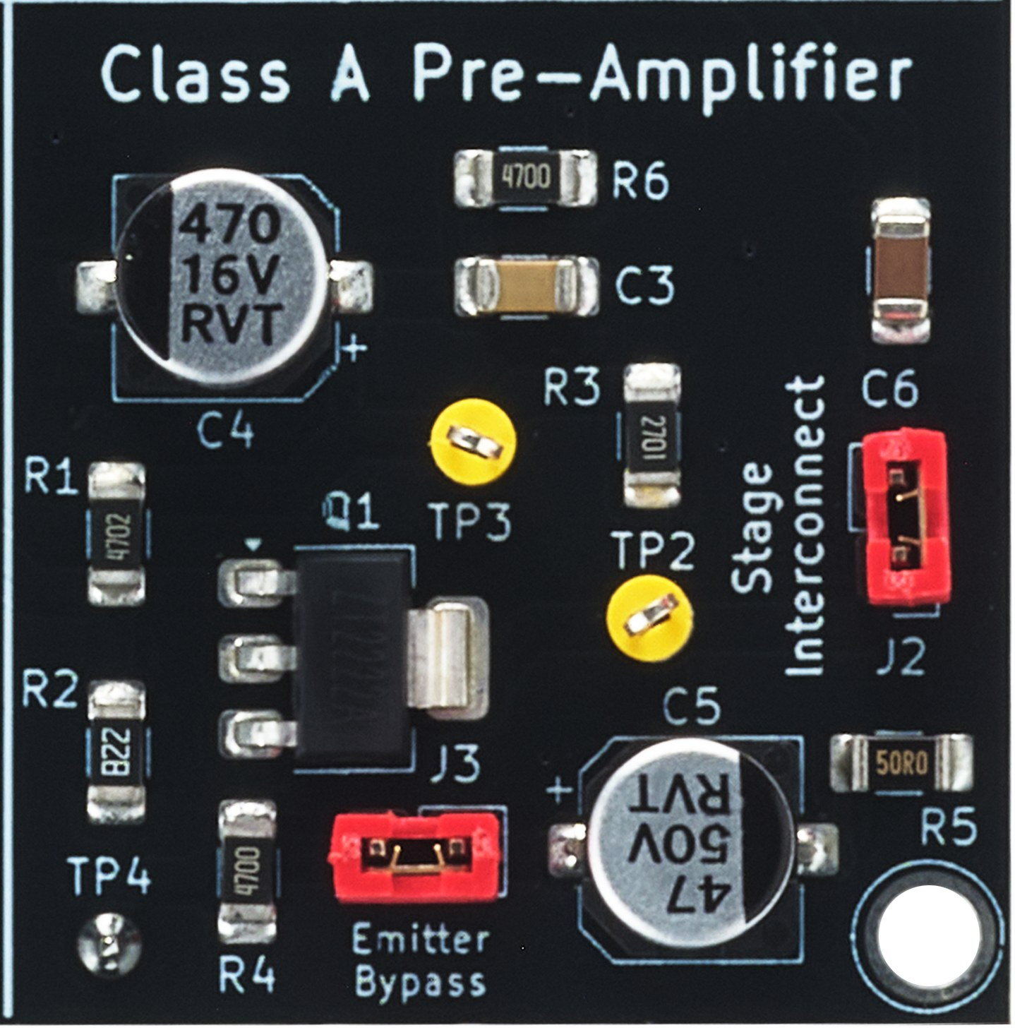
Q1 is a common-emitter amplifier and provides most of the voltage gain of the module. R1 and R2 form a voltage divider that sets the base bias voltage. R3 is the collector load and R4 is the emitter resistor, which stabilises the operating point against changes in transistor gain and temperature. The collector is set close to half the supply voltage so that the output can swing equally in both directions before clipping.
The stage is supplied from a separate filtered rail at TP3. R6, C3 and C4 stop current changes in the output stage from reaching the pre-amplifier supply, where they would be amplified again.

4.2.1 Emitter Bypass (J3)
With J3 open, the full emitter resistor R4 provides local negative feedback. The gain is low but very stable and linear.
With J3 fitted, C5 and R5 bypass R4 at audio frequencies and the gain increases. R5 limits the maximum gain and keeps the stage linear. At very low frequencies C5 no longer bypasses R4, so the bass response rolls off to the lower gain.

4.2.2 Stage Interconnect (J2)
J2 connects the pre-amplifier output to the driver stage. Removing J2 separates the two stages, so each stage can be tested on its own or a signal can be injected directly into the driver. The input of the driver stage loads the pre-amplifier, so the pre-amplifier gain is lower with J2 fitted.

4.3 Driver Stage
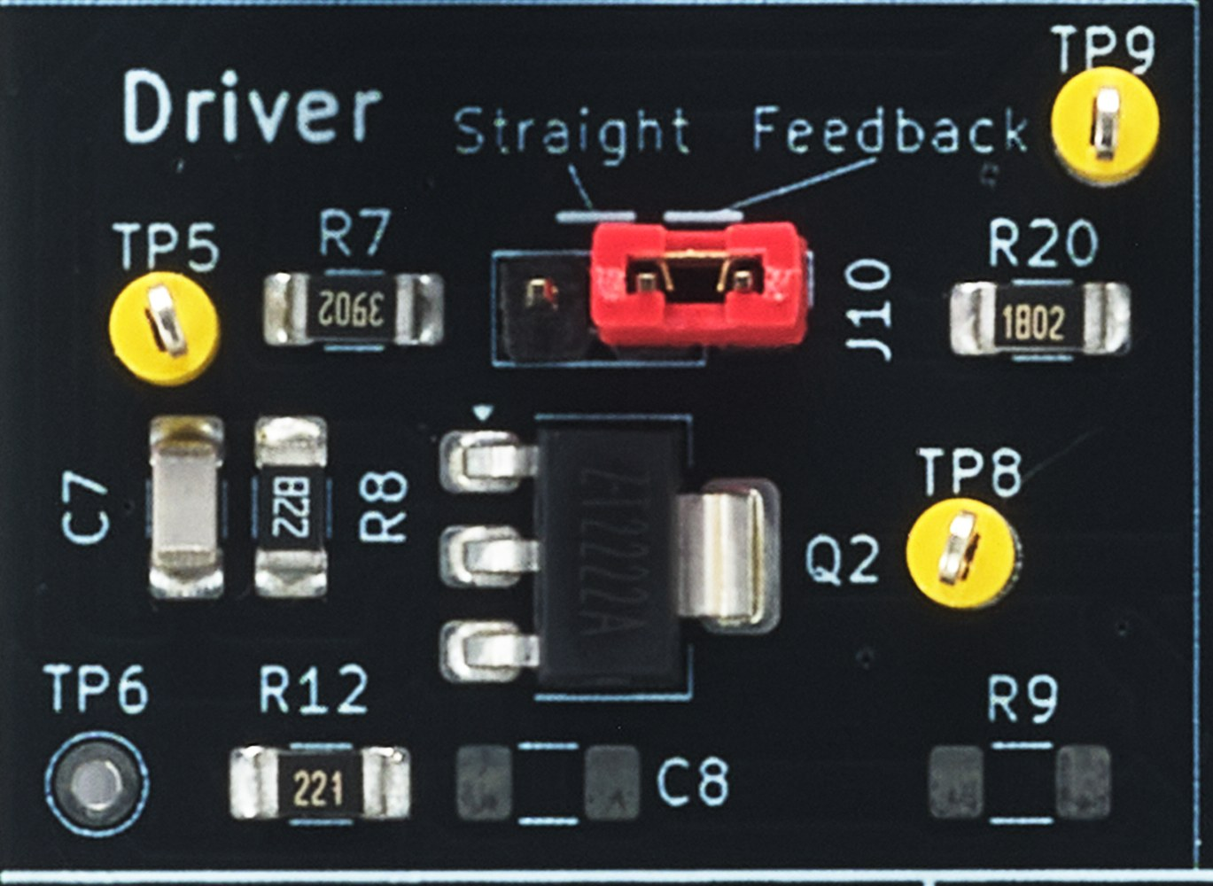
Q2 is the driver. It is a second common-emitter amplifier that provides the voltage swing needed by the output stage. The pre-amplifier output is coupled to its base through C6. R12 is the emitter resistor and R8 is the lower base bias resistor. C8 and R9 are not fitted and can be added to experiment with bypassing R12.
The collector current of Q2 flows from the supply through R10, through the bias network and into the Q2 collector. The voltage drop across R10 sets the DC voltage at the bases of the output transistors, and therefore the DC voltage at the output.
C7, connected from collector to base, reduces the gain at very high frequencies. This keeps the amplifier stable and prevents oscillation, without affecting the audio band.

4.3.1 Driver Bias – Straight or Feedback (J10)

Straight – R7 from the supply and R8 to ground form a fixed voltage divider. The output DC voltage depends on the supply voltage, the transistor gain and temperature. There is no signal feedback, so the gain is higher and the distortion is higher.

Feedback – R20 is connected from the output to the base of Q2 and forms a divider with R8. If the output voltage rises, Q2 conducts harder and pulls it back down; if it falls, the opposite happens. The output therefore stays close to half the supply voltage. The same path carries the audio signal back to Q2 as negative feedback, which reduces the gain and reduces distortion.

Why Feedback gives more output
In the Straight position the DC voltage at the output is set by a fixed divider and is rarely exactly at half the supply. One half of the waveform therefore reaches its limit before the other, and the output clips on that side first. In the Feedback position the output is held close to half the supply, so both halves have the same room to swing. The output can be driven further before either half clips, giving more clean output power.
Below clipping, the distortion is similar in both positions. The feedback only covers the driver and output stages, and most of the remaining distortion comes from the Class A pre-amplifier, which is outside the feedback loop.

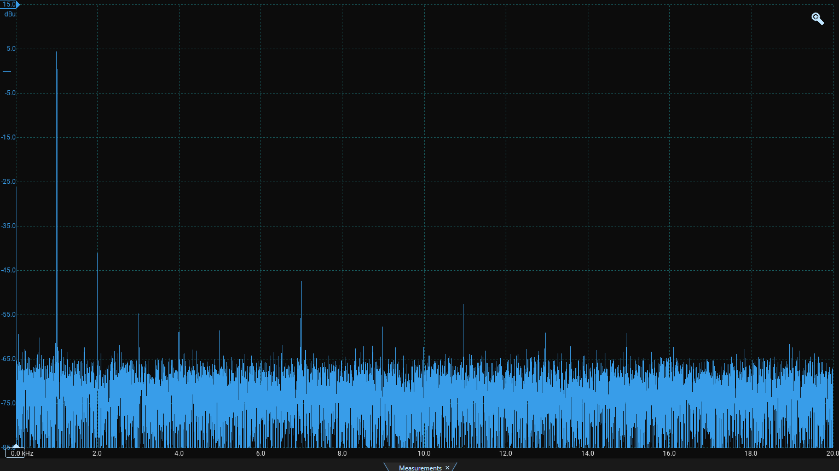
Distortion FFT – 8 Ω, 0.21 W, 1 kHz (J4 fitted, J10 Feedback, J7 VbeX)

Measured output 3.70 V pk-pk, THD 0.69 %

4.4 Bias Network (J7)
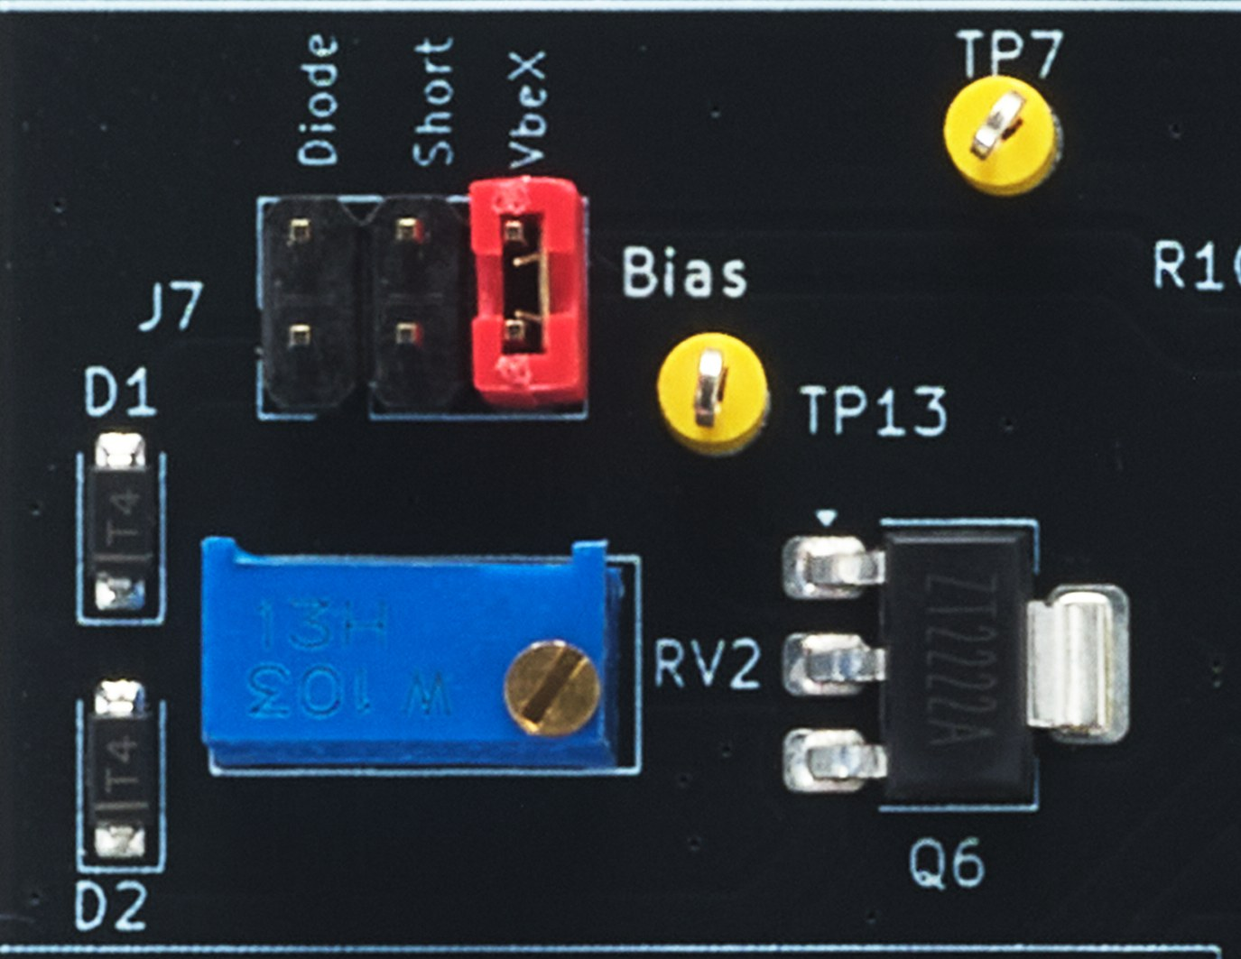
The bias network sets a small voltage between Bias+ (TP7) and Bias− (TP8), the bases of the two output transistors. Each output transistor needs a base-emitter voltage before it starts to conduct. The bias voltage holds both transistors just on, so that one takes over smoothly from the other as the signal passes through zero. J7 selects one of three options:
J7 Position | Bias | Output Stage Class
Short | None | Class B – crossover distortion
Diode (D1, D2) | Fixed – two diode drops | Class AB
VbeX (Q6, RV2) | Adjustable with RV2 | Class AB

4.4.1 Crossover Distortion
With J7 in the Short position the bases of Q3 and Q4 are joined. Around the zero crossing of the signal neither transistor conducts, and the output stays flat for a short time. This creates a notch at every zero crossing, known as crossover distortion. It sounds harsh and is most noticeable at low volume.
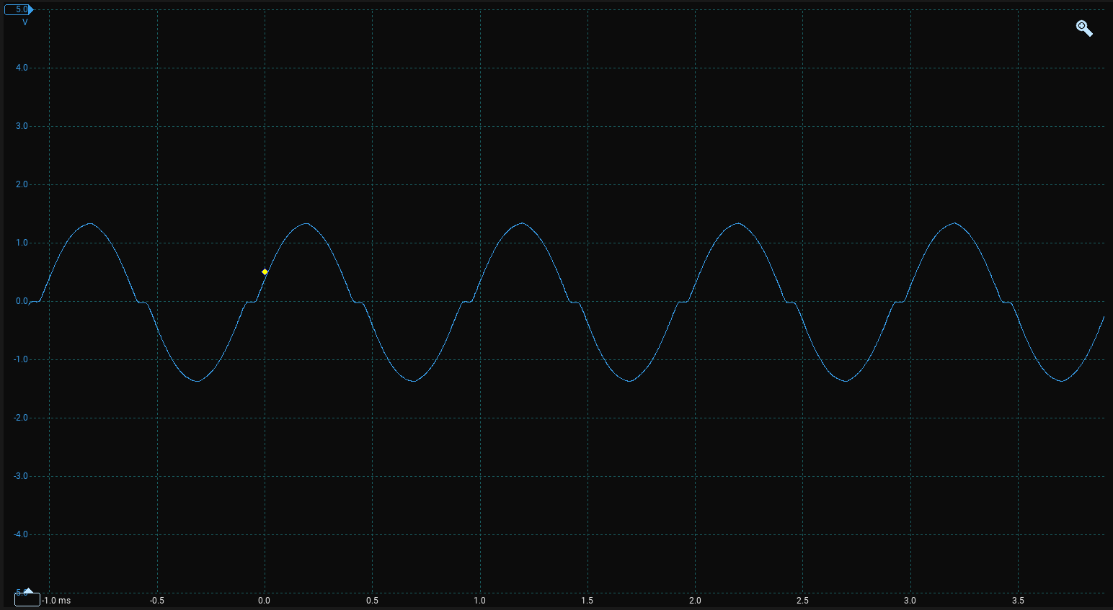
Class B – crossover distortion (J7 Short)
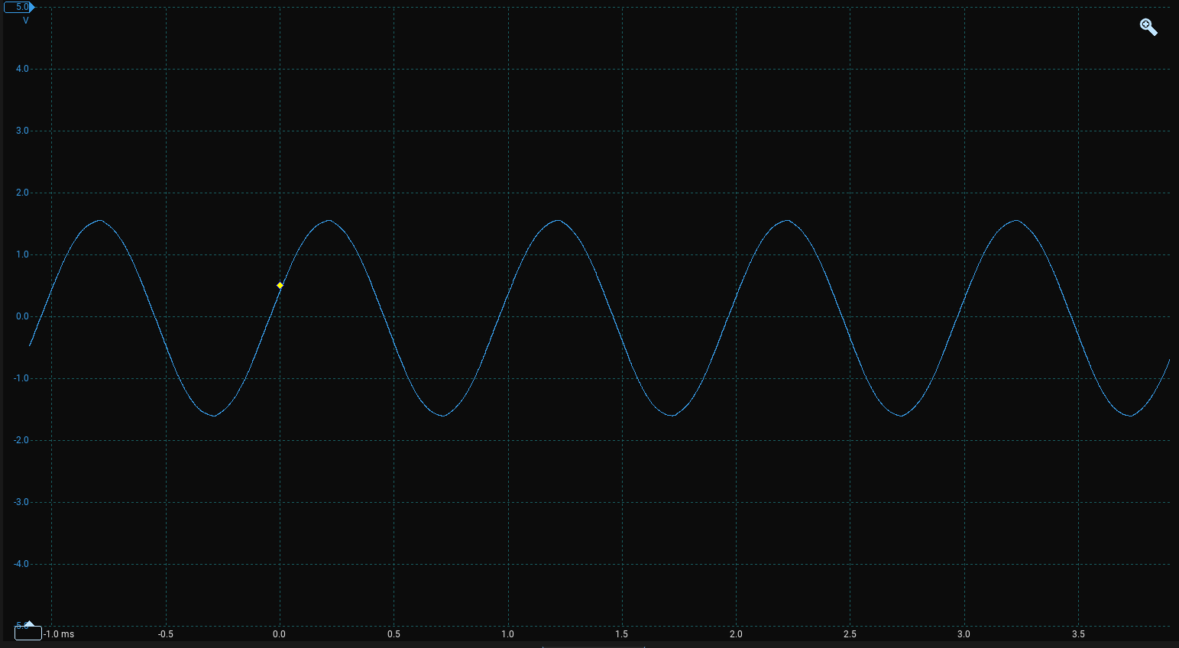
Class AB – crossover removed (J7 VbeX)

4.4.2 Diode Bias
D1 and D2 in series provide a fixed bias of two diode drops, which is close to the two base-emitter drops of Q3 and Q4. The diode voltage falls as temperature rises, in the same way as the transistor base-emitter voltage, so the bias partly tracks temperature.

4.4.3 VBE Multiplier
Q6 and trimmer RV2 form a VBE multiplier, sometimes called a rubber diode. RV2 divides the voltage across Q6 and feeds a fraction of it to the Q6 base. Q6 conducts until its own base-emitter voltage is reached, so the voltage across it is a multiple of one base-emitter drop. Turning RV2 changes that multiple and therefore the bias.
Because the bias is derived from a transistor junction, it tracks temperature in the same way as the output transistors. It can be set precisely to remove crossover distortion with the minimum idle current (see 2.5).

4.5 Push-Pull Output Stage
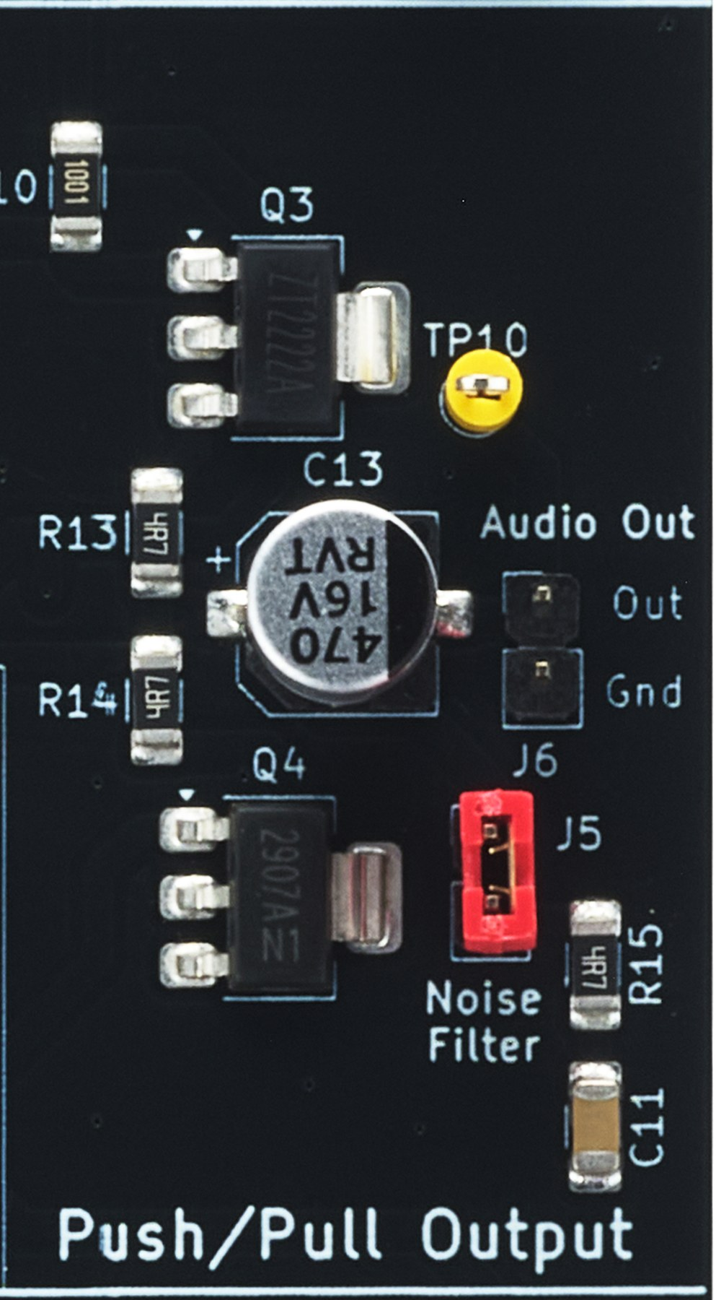
Q3 (NPN) and Q4 (PNP) are complementary emitter followers. Q3 supplies current to the speaker on the positive half of the signal and Q4 on the negative half. They provide current gain but no voltage gain. R13 and R14 are emitter resistors that share the current and stop the idle current rising as the transistors warm up. C10 and C12 decouple the supply to the output stage.
C13 blocks the DC voltage at the output from the speaker and passes the audio signal. A 4 Ω or 8 Ω speaker can be used. A 4 Ω speaker gives more output power but draws more current, so the current limit will act at a lower volume.

4.6 Zobel Network (Noise Filter J5)
R15 and C11 form a Zobel network from the output to ground. A speaker coil is inductive and its impedance rises with frequency. The Zobel network keeps the load seen by the amplifier resistive at high frequencies, which improves stability and removes high-frequency noise. Fit J5 for normal operation.

4.7 Current Limit
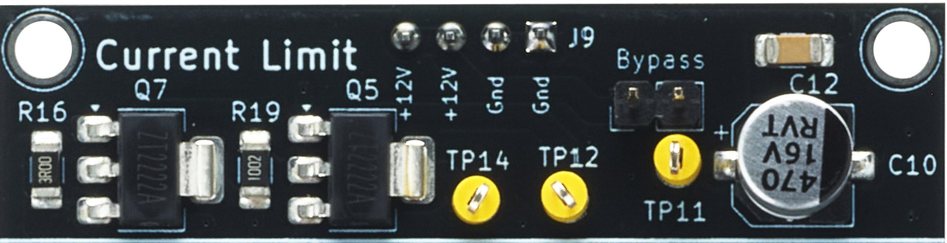
Q7 is a series pass transistor between the +12 V supply and the amplifier supply rail (TP11). Its base is driven from +12 V through R19. All of the amplifier current passes through the sense resistor R16.
Q5 monitors the voltage across R16. When the current becomes large enough for this voltage to reach about one base-emitter drop, Q5 turns on and takes base drive away from Q7. Q7 then limits the current to the amplifier. This protects the output transistors if the output is shorted or the bias is set too high.
Fitting J4 connects the amplifier directly to +12 V and bypasses the current limit.
Note
Do not leave the output shorted. Q7 becomes hot when it is limiting the current.

5.0 Signal Tracking

5.1 DC Test Point Voltages
The table below shows typical DC voltages with no input signal, J7 = Diode, J10 = Feedback and J3 fitted. All voltages are referenced to GND.
Test Point | J4 Open (Limit On) | J4 Fitted (Bypass)
TP11 – Amplifier rail | 9.6 – 10.4 V | 12.0 V
TP3 – Pre-amp rail | 8.9 – 9.6 V | 11.0 V
TP1 – Q1 base | 1.3 – 1.4 V | 1.55 V
TP4 – Q1 emitter | 0.6 – 0.7 V | 0.9 V
TP2 – Q1 collector | 5.4 – 5.6 V | 5.9 V
TP5 – Q2 base | 1.5 – 1.6 V | 1.8 V
TP6 – Q2 emitter | 0.8 – 0.9 V | 1.1 V
TP7 – Bias+ (Q3 base) | 5.8 – 6.2 V | 6.9 V
TP8 – Bias− (Q4 base) | 4.5 – 4.9 V | 5.6 V
TP9 – Output node | 5.2 – 5.5 V | 6.3 V
TP10 – Speaker | 0 V | 0 V

5.2 AC Signal Tracking
Apply a 1 kHz sine wave from an audio signal generator to J1, and adjust RV1 until the signal at TP1 is 80 mV pk-pk. Follow the signal through the amplifier with an oscilloscope.
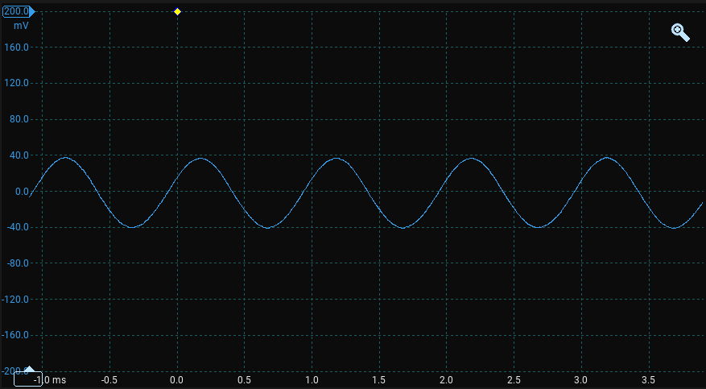
TP1 – Pre-amplifier input
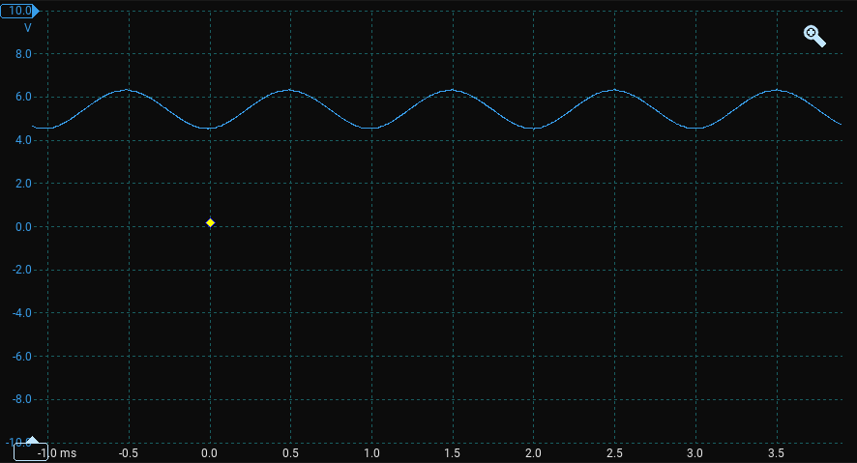
TP2 – Pre-amplifier output
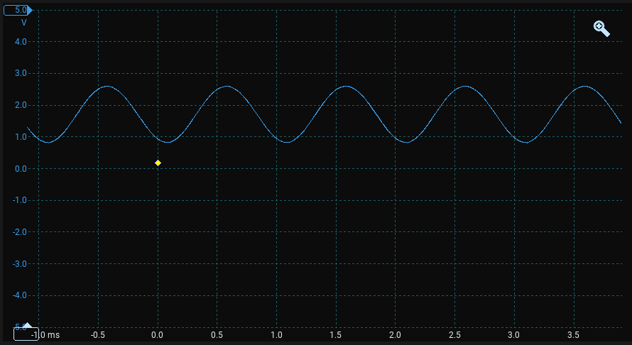
TP5 – Driver input
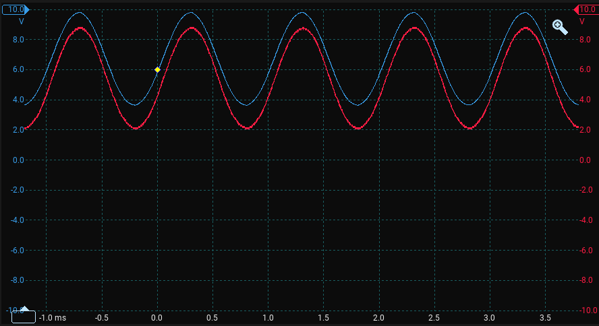
TP7 (blue) / TP8 (red) – Output stage bases
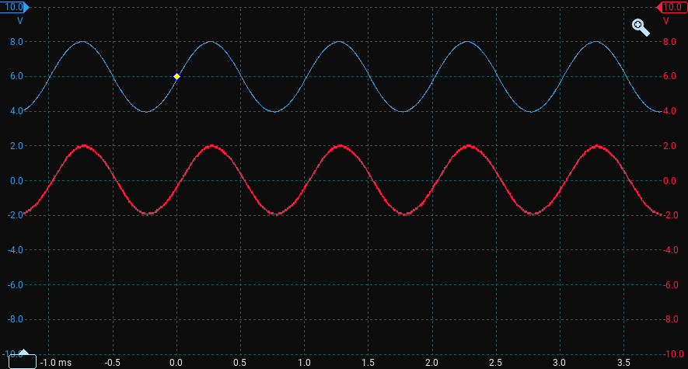
TP9 (blue) – Push-pull output, TP10 (red) – Speaker output

6.0 Experiments
The jumpers and test points on the module allow the following experiments. Use an audio signal generator as the signal source, and set RV1 for 80 mV pk-pk at TP1 unless the experiment says otherwise. An oscilloscope is recommended for most experiments.
Experiment | What to Do | What You Learn
1. Class B vs Class AB | Switch J7 between Short, Diode and VbeX. Listen and view TP10 on the oscilloscope. | What crossover distortion looks and sounds like, and how bias removes it.
2. Setting the bias | Adjust RV2 with J7 = VbeX from fully anticlockwise until crossover distortion disappears. | How a VBE multiplier sets the bias, and the trade-off between distortion and idle current.
3. Pre-amplifier gain | Fit and remove J3. Compare the signal at TP1 and TP2. | How emitter bypassing trades stability and linearity for gain.
4. Stage loading | Remove J2 and measure the pre-amplifier output. Refit J2 and measure again. | How the input of one stage loads the output of the previous stage.
5. Signal tracing | Follow the signal through TP1, TP2, TP5, TP7/TP8, TP9 and TP10. | How each stage changes the signal, and how to fault-find a multi-stage amplifier.
6. Straight vs feedback | Switch J10 and measure the DC voltage at TP9. Compare the FFT of TP10. | How negative feedback stabilises the operating point and reduces distortion.
7. DC operating points | Measure the test point voltages with no signal for each J7 and J10 setting. | How bias networks set the operating point of each transistor.
8. Clipping | Increase the volume until the output clips. Note which half of the waveform clips first. | The limits of output swing and what sets them.
9. Current limit | Drive the output hard with J4 open, then with J4 fitted. | How active current limiting protects the output stage.
10. Zobel network | Remove J5 and view the output with a square-wave input. | How a Zobel network improves stability with an inductive speaker load.
11. Speaker load | Compare a 4 Ω and an 8 Ω speaker. | How load impedance affects output power, current and current limiting.
12. Frequency response | Change the signal generator frequency from 50 Hz to 10 kHz and measure the output at each frequency. | How coupling and bypass capacitors set the low-frequency response.
13. Driver emitter bypass | Fit C8 and R9 on the driver stage and compare the gain and distortion. | How emitter bypassing affects the driver stage.

7.0 Assembly
The Class AB Audio Amplifier Module is supplied assembled. Only the power header needs to be fitted. The following is the kit of parts.
Part | Qty
Assembled Audio Amplifier PCB | 1
4 Pin Header | 1

7.1 Step 1 - Power Header
Insert and solder the 4 pin header on the underside of the board in J9.

7.2 Step 2 - Complete Assembly

